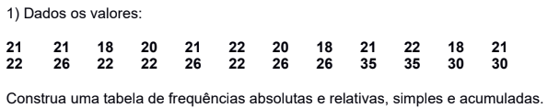

| **VALORES** | **ABSOLUTAS** | | **RELATIVAS(%)** | |
| --- | --- | --- | --- | --- |
| **Simples** | **Acumuladas** | **Simples** | **Acumuladas** |
| **18** | **3** | **3** | **12,5** | **12,5** |
| **20** | **2** | **5** | **8,3** | **20,8** |
| **21** | **5** | **10** | **20,8** | **41,6** |
| **22** | **6** | **16** | **25,0** | **66,7** |
| **26** | **4** | **20** | **16,7** | **83,6** |
| **30** | **2** | **22** | **8,3** | **91,6** |
| **35** | **2** | **24** | **8,3** | **100,00** |
| **TOTAL** | **24** | **-** | **100,0** | **-** |

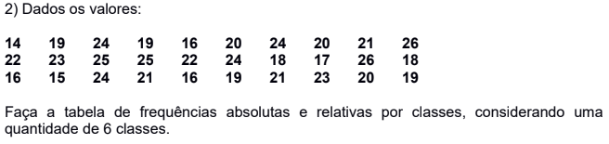

| **VALORES** | **ABSOLUTAS** | | **RELATIVAS(%)** | |
| --- | --- | --- | --- | --- |
| **Simples** | **Acumuladas** | **Simples** | **Acumuladas** |
| **12-14** | **1** | **1** | **3,3** | **3,3** |
| **15-17** | **5** | **6** | **16,7** | **20** |
| **18-20** | **9** | **15** | **30,0** | **50,0** |
| **21-23** | **7** | **22** | **23,3** | **73,3** |
| **24-26** | **8** | **30** | **26,7** | **100,0** |
| **26<** | **0** | **30** | **0** | **100,0** |
| **TOTAL** | **30** | **-** | **100,0** | **-** |

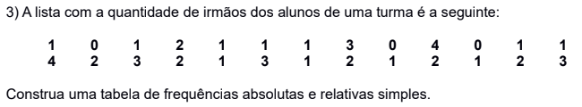

| **IRMÃOS** | **FREQUENCIA**  **ABSOLUTA** | **FREQUENCIA**  **RELATIVA** |
| --- | --- | --- |
|
| **0** | **3** | **0,12** |
| **1** | **11** | **0,42** |
| **2** | **6** | **0,23** |
| **3** | **4** | **0,15** |
| **4** | **2** | **0,08** |
| **TOTAL** | **26** | **1,00** |

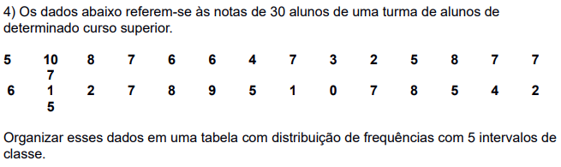

| **NOTAS** | **ABSOLUTAS** | | **RELATIVAS(%)** | |
| --- | --- | --- | --- | --- |
| **Simples** | **Acumuladas** | **Simples** | **Acumuladas** |
| **0-2** | **3** | **3** | **10** | **10** |
| **2-4** | **4** | **7** | **13,3** | **23,3** |
| **4-6** | **7** | **14** | **23,3** | **46,6** |
| **6-8** | **10** | **24** | **33,3** | **79,9** |
| **8-10** | **6** | **30** | **20** | **100** |
| **TOTAL** | **30** | **-** | **100** | **-** |